**Hope Artificial Intelligence**

**Scenario Based Learning**

A company works with number of employees, all the works are dependents on the employees. Even if one of the employees resign the job immediately then assigned work will be not finished at the time, so delivery of the project to the clients will be delayed. Company planned to make solution for this, they want to know which employee may resign next. If they know previously, they can arrange alternative to avoid such problem. As an AI Engineer you must give Solution to this.

1.How will you achieve employee this in AI?

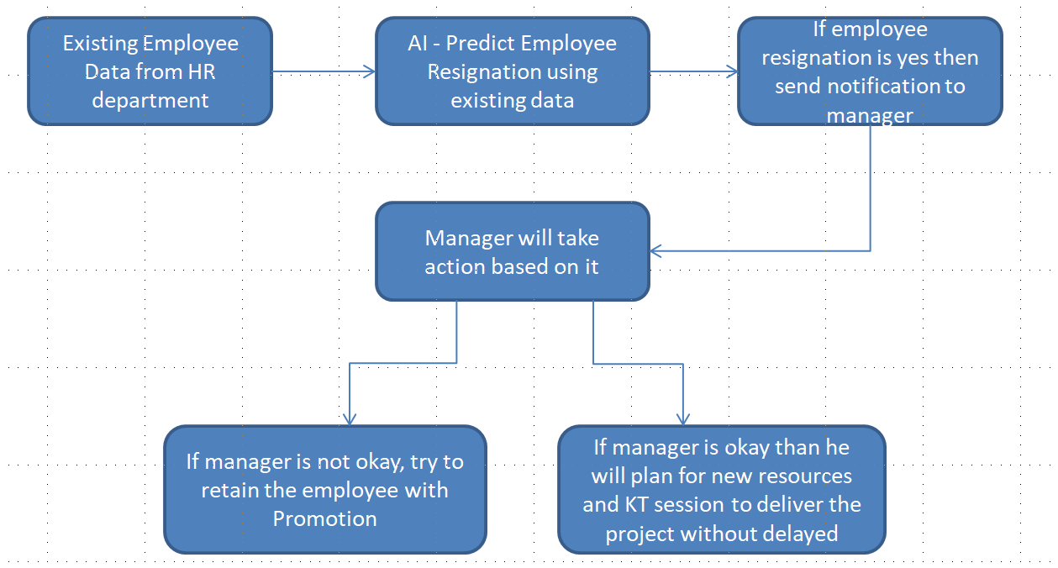

Input we can take Employee Id and Resignation status like 1 or 0 (Yes-1, No-0) from existing data from HR side then AI Predicting an employee’s about resignation within the next 30, 60, or 90 days. Based on this data, output will be employee “resigned within N days” or “not resigned within N days”.

Here N will be 30 or 60 or 90

Output of AI would help to bring this information to manage notice by email or message so that manager can take the decision accordingly. If Manager isn’t okay with employee resignation then he tries to retain that employee in that company. If Manager is okay then he will plans for new resources taking and giving KT to them from resigning employee to avoid dependency and deliver the project on time.

2. Find out the 3-stage of Problem Identification



**Why ML**

Input – Employee ID/Resignation Status – Number

**Why Supervisor**

Requirement is clear – Have to predict the how many employees going to resign

Output is clear -> Resign/ Not Resign

**Why Classification**

Output looks categorical values (Resign/ Not Resign) so its comes under Classification

3. Name the Project

**Predict Employees Resignation**

4. Create the dummy Dataset

|  |  |  |  |  |  |  |  |
| --- | --- | --- | --- | --- | --- | --- | --- |
| Employee Id | Employee Name | Department | Designation | Age | Sex | Resignation Status | Date of Resignation |
| Karthick | 27368 | ADM | Software Engineer | 32 | Male | Yes | 30-01-2024 |
| Raghul | 34567 | AIA | Data Analyst | 29 | Male | No | Null |
| Venba | 67546 | QA | Software Tester | 28 | Female | Yes | 30-11-2023 |
| Arul | 23561 | ADM | Jr. Software Engineer | 23 | Male | No | Null |
| Kayal | 45678 | ADM | Technical Lead | 40 | Female | No | Null |